- Use the Employee Details dataset and perform the following activities: -

− Split the column CITY and separate the code associate with each city like - Allahabad[AL2] should be only Allahabad and [A2] will be separate .
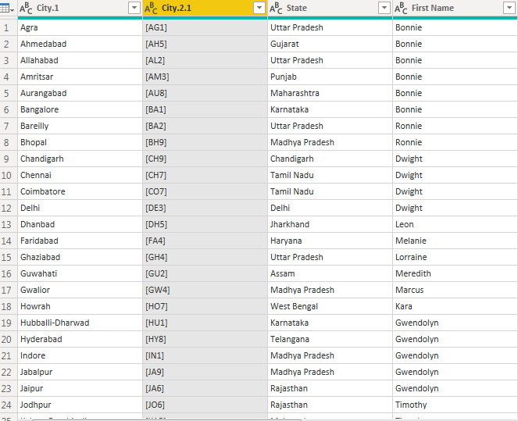
Extract the first name from EMPLOYEE NAME column and transform the column

Using the JOINING DATE column extract the Year and no. of days for that month

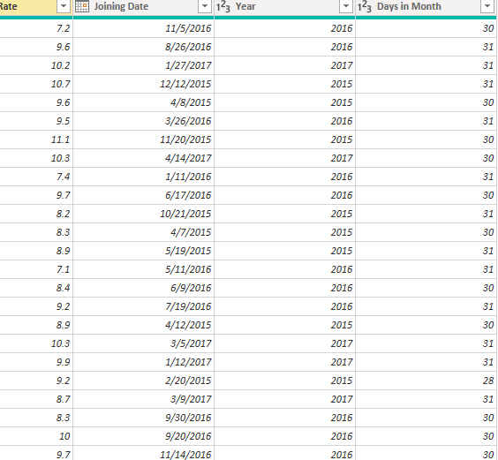

Create a visual of your choice and show the how much salary has been paid to each state and which state has lowest payout.

